Levels of Writing Group Response

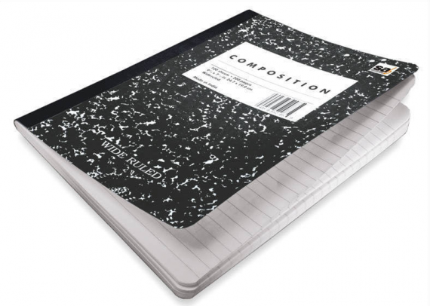

Bless: When a student requests “bless,” he asks for his peers to note only the things they like about the paper. Elements they might bless include the diction, the sentence structure, the introduction and/or the conclusion, the sequencing, realistic use of dialogue, or a favorite segment of the paper. When the writer requests “bless,” there is no criticism of the paper allowed. All comments are positive. Hakuna matata only.

Address: When a student requests “address,” she is asking for her peers to look at a very specific element of the paper. For example, a student might ask the others in the group to pay close attention to a particular section of the paper she is having trouble with and to offer some thinking on how to work through the difficulty. When a student asks for “address,” she dictates exactly where in the paper she would like her fellow group members to focus their feedback.

Press: When a student requests “press,” he is indicating to his partners that all comments are welcome. Partners can offer constructive criticism, praise, and/or suggestions. Anything goes-provided the feedback helps the writer to make the paper better.

