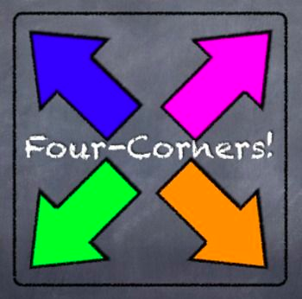

 | Responses & Rationales
Quick-Write & Groups’ Discussion Summaries | Quick summary of the prompt I chose:
A

B

C

D

